LAB ASSIGNMENT-2.2

2303A52353
Batch-37
Question:-
Lab 2: Exploring Additional AI Coding Tools beyond Copilot – Gemini (Colab) and Cursor AI

Task 1: Cleaning Sensor Data
❖ Scenario:
❖ You are cleaning IoT sensor data where negative values are invalid.
❖ Task:
Use Gemini in Colab to generate a function that filters out all negative
numbers from a list.
❖ Expected Output:
➢ Before/after list
➢ Screenshot of Colab execution
Prompt:
Given a list of numbers, separate them into two new lists: one for negative numbers and another for non-negative numbers. Then, print the original list, the negative numbers, and the non-negative numbers.
Code:
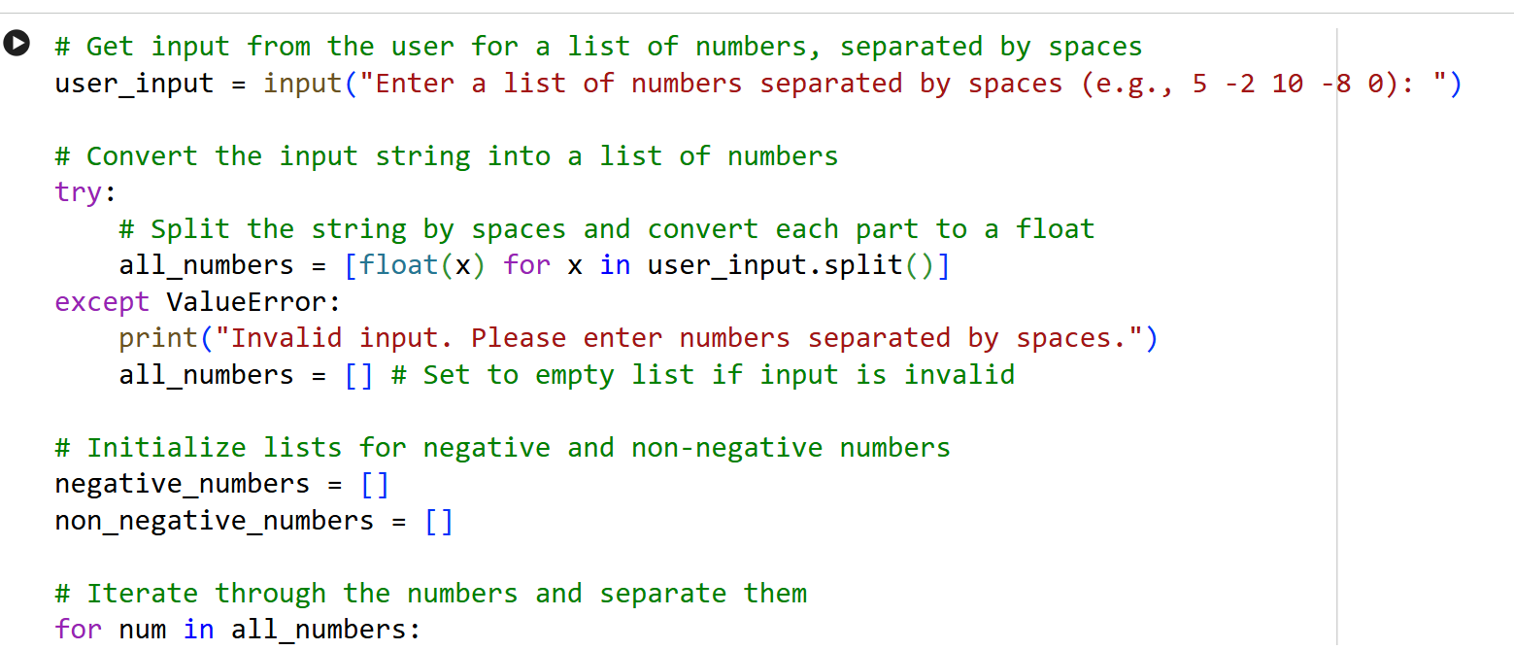
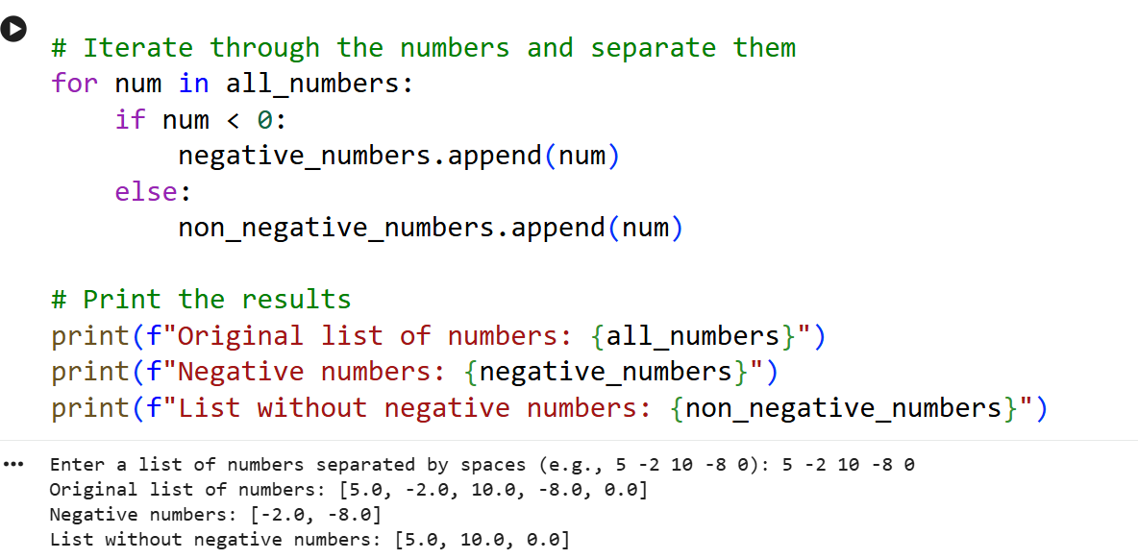
Explanation:
The program asks the user to enter numbers separated by spaces and reads the input as a string.
It tries to convert each value into a float; if conversion fails, it shows an error and uses an empty list.
Two empty lists are created to store negative and non-negative numbers separately.
The program loops through the numbers and places each one into the appropriate list based on its value.
Finally, it prints the original list, the negative numbers, and the list without negatives.
Question-2:
Task 2: String Character Analysis
❖ Scenario:
You are building a text-analysis feature.
❖ Task:
Use Gemini to generate a Python function that counts vowels, consonants,
and digits in a string.
❖ Expected Output:
➢ Working function
➢ Sample inputs and outputs
Prompt:
Create a Python function that counts the number of vowels, consonants, and digits in a given string. Afterwards, show how to use this function with an example string and print all the resulting counts.
Code:
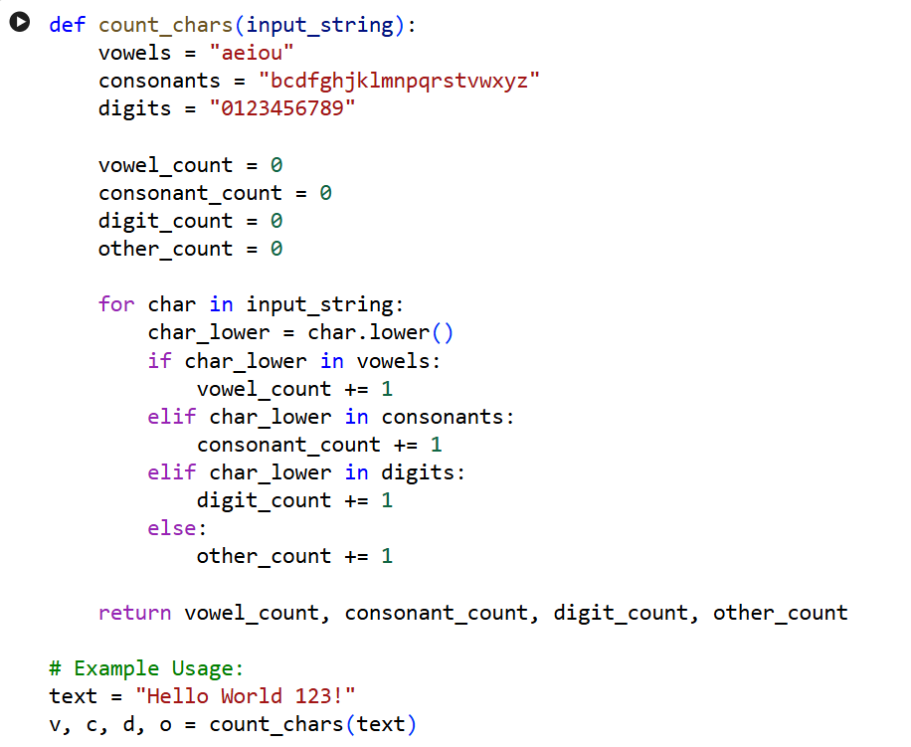
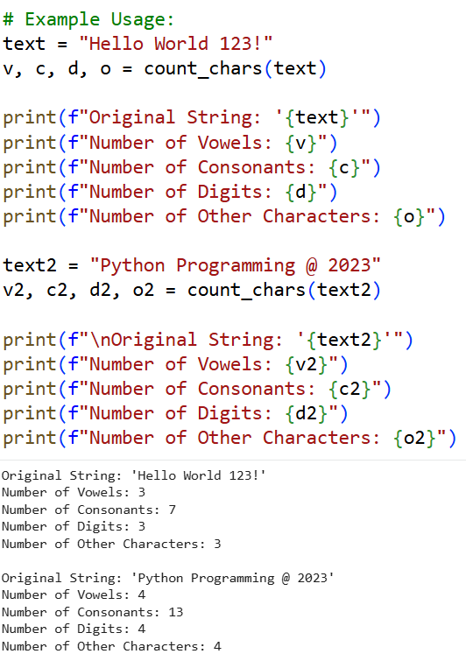
Explanation:
The function count_chars defines vowels, consonants, and digits, and initializes counters for each category.
It loops through every character in the input string and converts it to lowercase for consistent checking.
Each character is classified as a vowel, consonant, digit, or other character and counted accordingly.
The function returns the four counts as a tuple.
The example code calls the function with sample strings and prints the results.

Question-3:-
Task 3: Palindrome Check – Tool Comparison
❖ Scenario:
You must decide which AI tool is clearer for string logic.
❖ Task:
Generate a palindrome-checking function using Gemini and Copilot, then
compare the results.
❖ Expected Output:
➢ Side-by-side code comparison
➢ Observations on clarity and structure
Prompt:
Write a Python program using a function to check whether the given text is a palindrome or not.
The program should take input from the user and display an appropriate message based on the result.
Code:
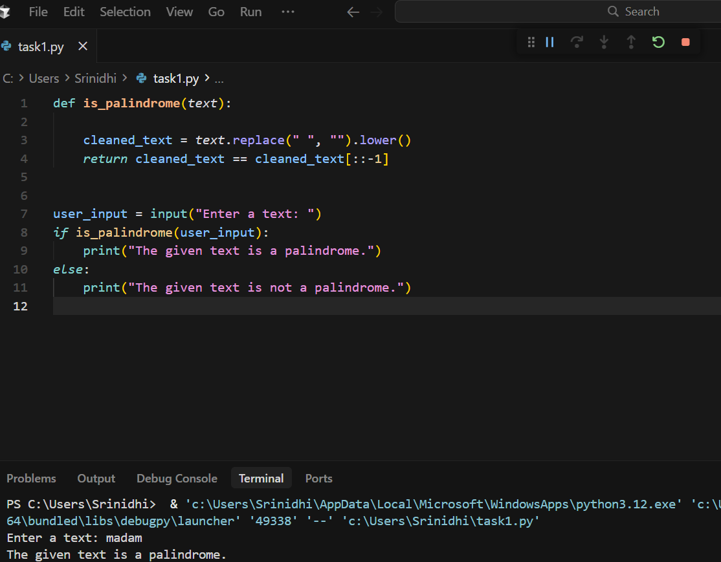
Explanation:
The function is_palindrome removes spaces from the text and converts it to lowercase.
It checks whether the cleaned text is the same when reversed.
The program asks the user to enter a text using input().
The function is called with the user’s input to test if it is a palindrome.
Based on the result, an appropriate message is printed.
Question –4:-
Task 4: Code Explanation Using AI
❖ Scenario:
You are reviewing unfamiliar code written by another developer.
❖ Task:
Ask Gemini to explain a Python function (prime check OR palindrome
check) line by line.
❖ Expected Output:
➢ Code snippet
➢ AI explanation
➢ Student comments on understanding
Prompt:
Write a Python program using a function to check whether a given number is a prime number or not.
The program should test the function with sample numbers and display the results.
Code:
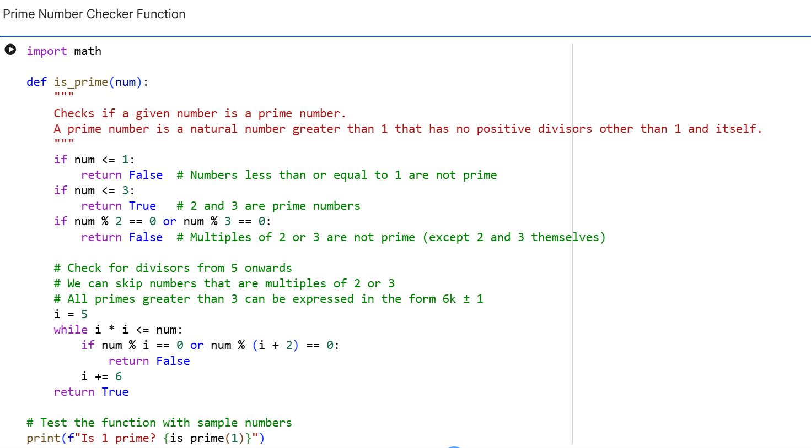
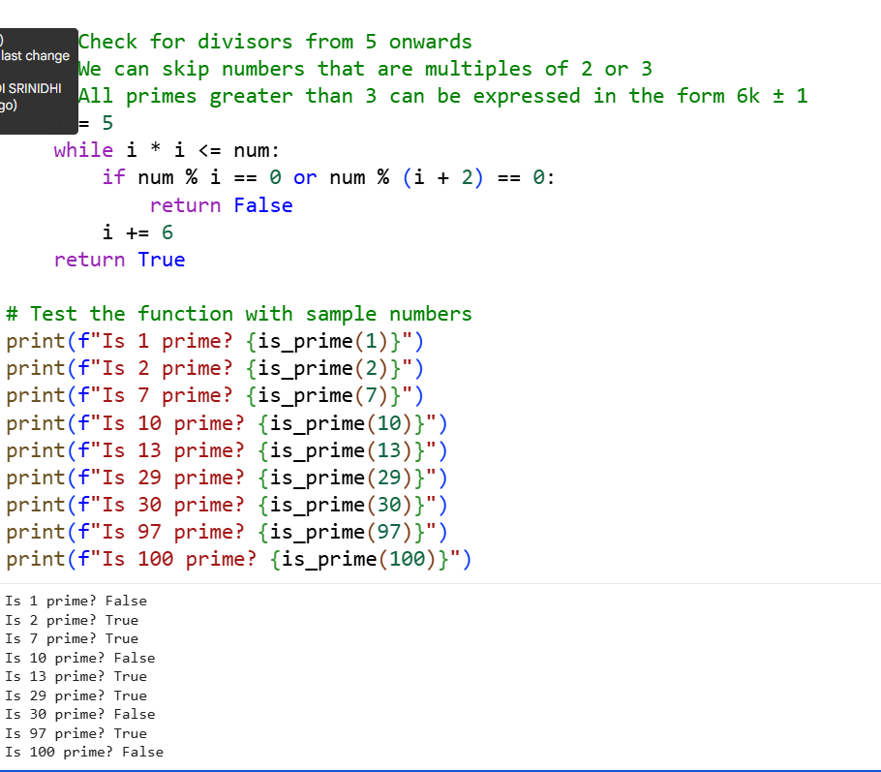
Explanation:
The is_prime function checks whether a number is prime by handling small and invalid cases first.
It immediately returns False for numbers less than or equal to 1 and True for 2 and 3.
The function eliminates numbers divisible by 2 or 3 to reduce unnecessary checks.
It then checks possible divisors using the pattern 6k ± 1 up to the square root of the number.
The program tests the function with several sample numbers and prints whether each is prime.

